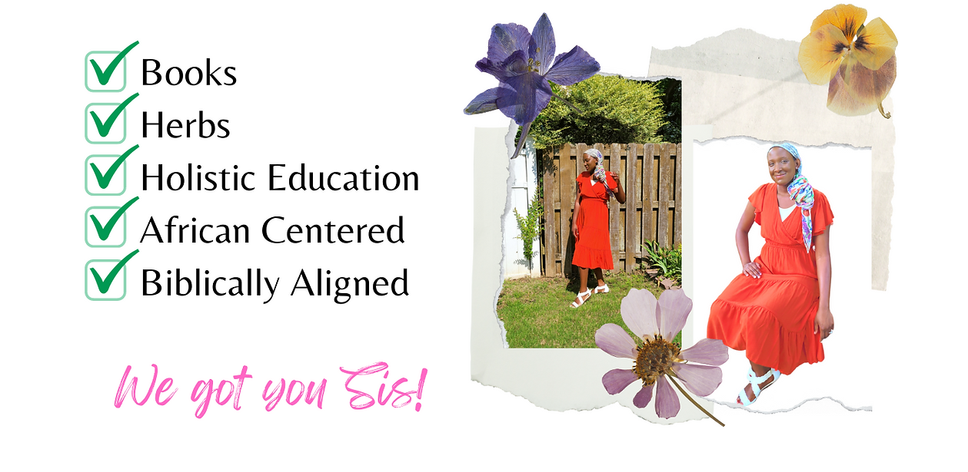
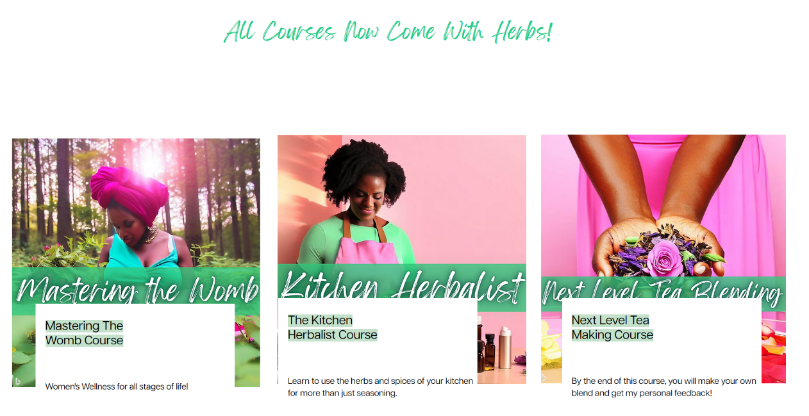
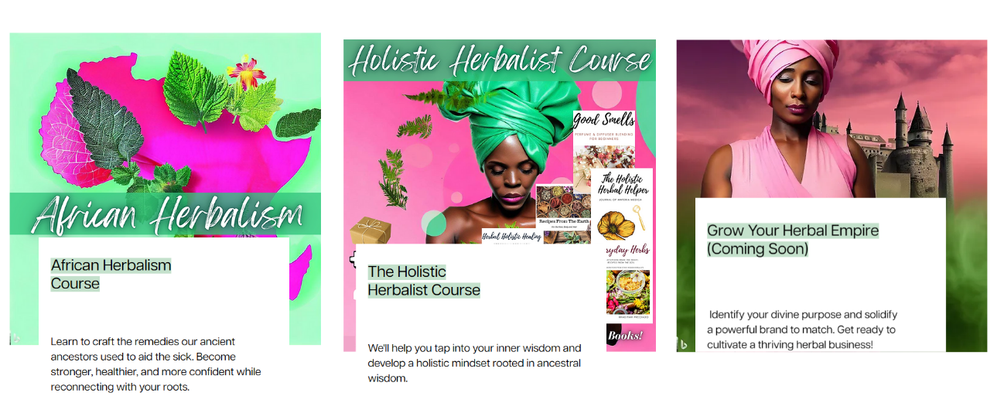
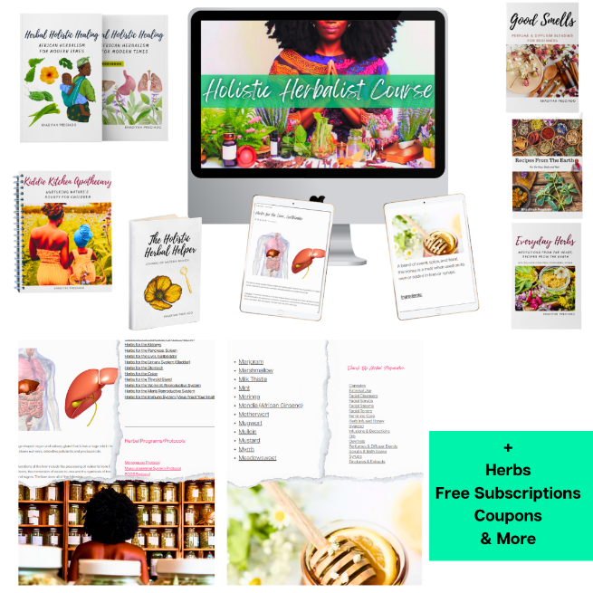
All of our courses come with access to

At least 1 book and a Kit of Herbs
24 Hour Priority Response
25% Discount on Books, 15% off herbs
Certificate of Completion

For your convenience,

- Progress is instantly tracked by manually checking lessons as completed.

- Course videos and notes can be downloaded to refer to offline.

- Videos can be sped up or slowed down by changing the playback speed.

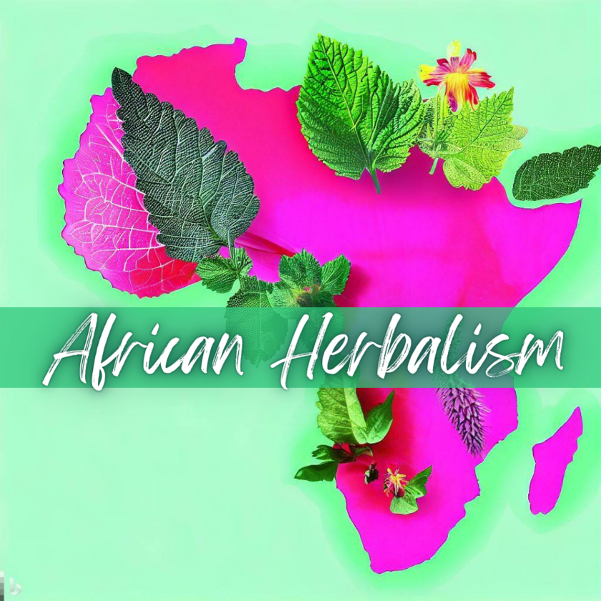
Enjoy access to a private group just for students.

Get a huge discount on our student Herb starter Kit.

Get exclusive discounts on the purchase of the Practitioner Database and Library of Herbal Wisdom Plans.

Plus enjoy miscellaneous coupons just for students from our partners!

Table of Contents

Course Comparison 4
Next Level Tea Making: Blending Like A Boss! 5
Kitchen Herbalist Course 8
African Herbalism Course 10
The Holistic Herbalist Course 12
Mastering the Womb Course 15

Course Comparison

Course | Next Level Tea Making | Kitchen Herbalist Course | African Herbalism Course | Holistic Herbalist Course
# of Steps | 25 | 49 | 42 | 71
# of Videos | 10 | 35 | 24  7+ Hours | 24  18+ Hours
# of Herbs | 25+ | 15+  Culinary  Herbs | 40+  African, Indigenous Herbs | 100+  Includes Herbs from multiple continents!
# of Months to Complete | 3-6 (180 days to complete) | 3-6 months (self-paced) | 6-12 (self-paced) | 6-24 (self-paced)
Level of Expertise (once completed) | Beginner to Intermediate | Beginner to Intermediate | Intermediate | Advanced
Herbs  Mentioned | Chamomile  Calendula  Raspberry Leaf  Red Clover  Marshmallow  Hibiscus  Lemon Balm  Lemongrass  Mint  Nettle  Blue Malva  Anise Seed  Fennel Seed  Oat straw  Milky Oats  Stevia  Lavender  Catnip  Peppermint | Cilantro  Basil  Thyme  Oregano  Cayenne  Ginger  Turmeric  Fennel  Dill  Lavender  Mint  Chamomile  Onion  Garlic  Honey  Aloe | Moringa  Black seed  Marshmallow  Hibiscus  Vervain  Tulsi Basil  Wormwood  Honeybush  Rooibos  Gymnema  Neem  Hoodia  Bacopa  Thistle  Periwinkle  Nettle  Mullein  Anise Seed  And more | African Herbs,  European Herbs,  Chinese Herbs,  Indian Herbs,  Plus others  Burdock, Hyssop, Dandelion,  Damiana, Skullcap,  Chickweed, Sarsaparilla, Neem, Moringa, Chaga, Reishi, Astragalus, Willow bark, Yellow dock, Mullein, Plantain and etc.
Course | Mastering the Womb Course | Grow Your Herbal Empire Course
# of Steps | 62 | 26 + includes all courses
# of Videos | 22 | 11+ Includes all course videos
# of Herbs | 25+ | All the Above
# of Months to Complete | 3-6 (180 days to complete) | 24 months (self-paced)
Level of Expertise (once completed) | Intermediate | Advanced
Herbs  Mentioned | Chamomile  Calendula  Raspberry Leaf  Red Clover  Marshmallow  Mint  Nettle  Fenugreek Seed  Anise Seed  Fennel Seed  Oat straw  Milky Oats  Lavender  Catnip  Peppermint  And more | All the above  This is a special package that includes all of the courses, plans, books and etc.  Please view the details here.

Next Level Tea Making: Blending Like a Boss!

View

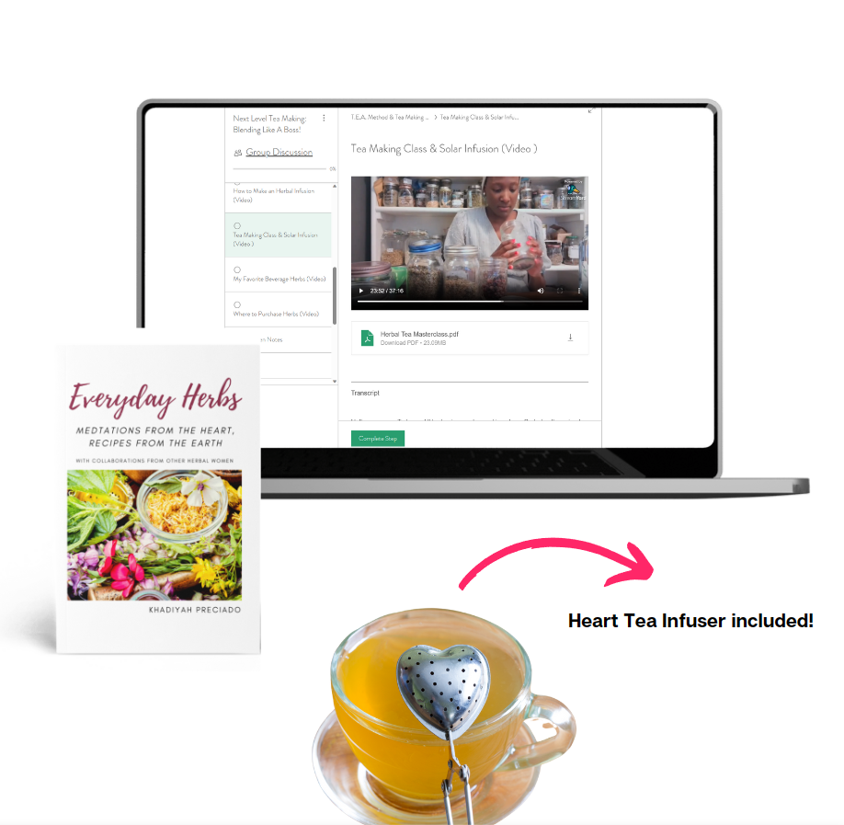

Boxed teas are boring, dull and lifeless. I know that's harsh-but it's true. It is often cheaper to make your own tea at home, it will taste better, and it might even be more potent. Traditional tea bags have glue and toxic chemicals in with the purported medicinal benefits of the herb. The big box manufacturers aren't even herbalists! It's time for a change!
Tea blending is an art, you can't just throw ingredients into a bowl and expect it to be tasty and effective. You need to know about tastes, actions and energetics, before you make your blend. By learning about these components-you'll actually know a lot more than the herbalist next door.
In this course you will learn how to make your tea blends that look stunning and taste amazing. You'll learn my coveted T.E.A. Method to make the perfect tea blend every time. You'll also learn the top herbs I think every household should have! And most importantly, you'll snag my yummy tea blends to try at home! This course provides access to downloadable and recipes notes- so you can reference them later and share with a friend! We will explore herbal infusions, decoctions, and sun teas. Bring your herbs and a mug! Access to at least 10 beverage herbs is recommended.

Craft your own fully custom blends
Learn which herbs are needed for your apothecary or herbal business!
Learn how to create formulas using multiple methods!
Confidently make herbal infusions, decoctions and sun teas. 🫖

By the end of this course, you will make your own blend and get my personal feedback!

Bonuses
Herb Starter Kit (Chamomile, Hibiscus, Raspberry Leaf, Nettle & Lavender) to make your first creations.
Physical Copy of Everyday Herbs to try my delicious recipes.
Sample Client Consult Form for gathering important client information.
Herb Drug Interaction Video to avoid contraindications.

Kitchen Herbalist Course

View

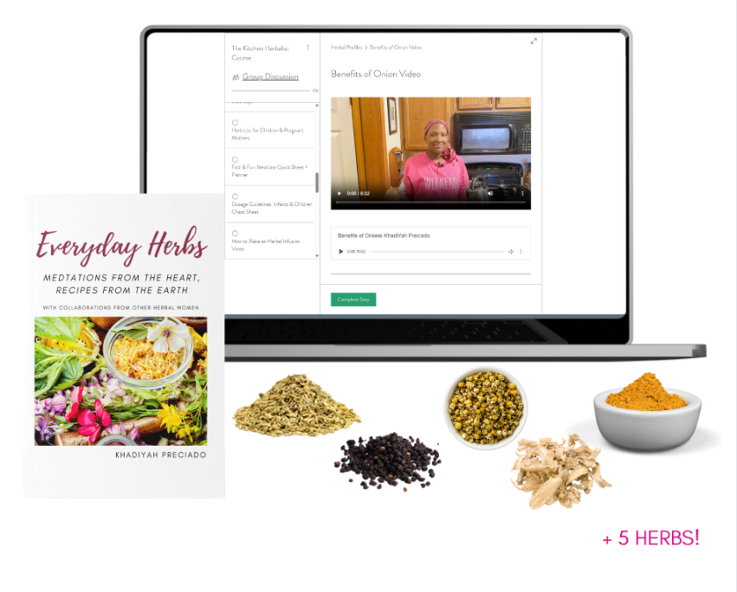

Trying something new is often scary and overwhelming. You're afraid to mess up, or worse, poison yourself, by "doing it wrong". That's why I propose kitchen herbs for beginner herbalists who want to get their feet wet. Culinary herbs are a no brainer; you already enjoy them, you know where to find them and how to use them in and as food. Fortunately, many of these herbs have little contraindications and can be used safely by most people.

Fill your apothecary in just 10-20 minutes a day,
Cut your otc and prescription 💊 costs,
Learn what to actually do with the leftover herbs you are already buying 🌿,
Comfortably treat a variety of ailments in house and quickly,
Craft delicious recipes that your hubby and kids will eat (and supplement their nutrition with ease),
Be prepared for the times ahead,
Get the Most High's stamp of approval by returning to Eden!

Make your very own

Herbal Bone Broth Herb Vinegar
Extracts Herbal Syrup
Herb Infused oil
Oxymel
Poultice
Capsules & Powders
Extracts & Tinctures & more

This plan includes

30+ Videos
BONUS lesson on Herb Drug Interactions
Downloadable Recipe Cards & Notes
25% Discount on Books
Certificate of Completion*
Turn your home cookin' into food that's nourishing from the inside out.

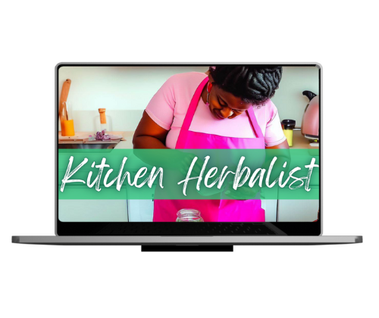

African Herbalism Course

View

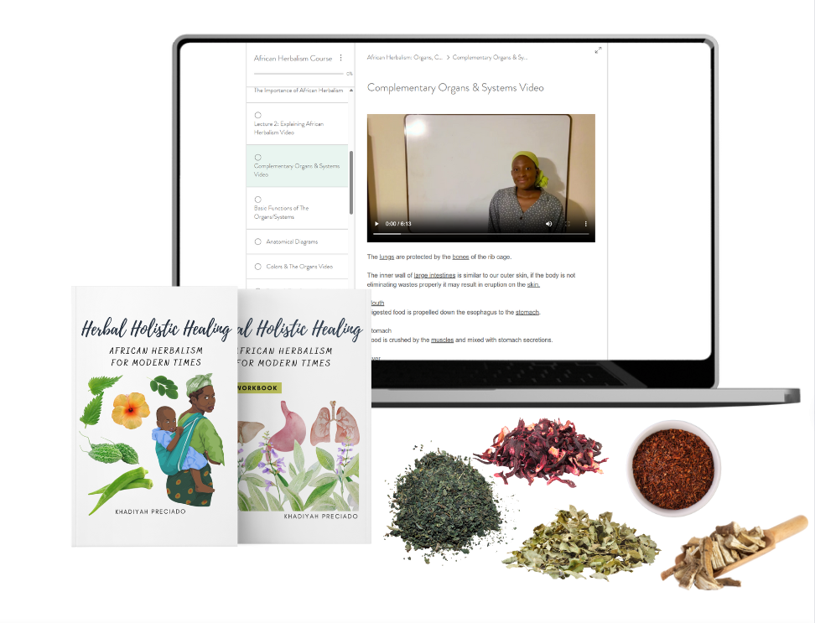

The transatlantic slave trade stripped our ancestors of almost everything- but it could not take the knowledge within. In this course we'll UNLOCK the ancient, sacred teachings of the herbs that different African peoples and cultures have thousands of years of experience with. These herbs are filled with a diversity of nutritional benefits and constituents. They are antioxidant rich, and address the issues that plague the Black community such as diabetes and hypertension... Africans were the first people to truly recognize the uses of herbs, so to have a deep understanding, you must first learn from them.
I'm unlocking Africa's secrets and returning a piece of our history to us:

Learn to craft the remedies our ancient ancestors used to aid the sick.
Become stronger, healthier, and more confident while reconnecting with your roots.

You'll receive a “Taste of Africa Kit ", which includes the following:
Marshmallow Root
Hibiscus
Rooibos or Honeybush
Moringa
Stinging Nettle

Reconnect with our heritage and build a legacy by joining the family today!

Includes a Paperback of Herbal Holistic Healing + The Workbook
Bonus Videos: Herb Safety & Drug-Herb Interactions
Virus Proof Your Health

The Holistic Herbalist Course

View

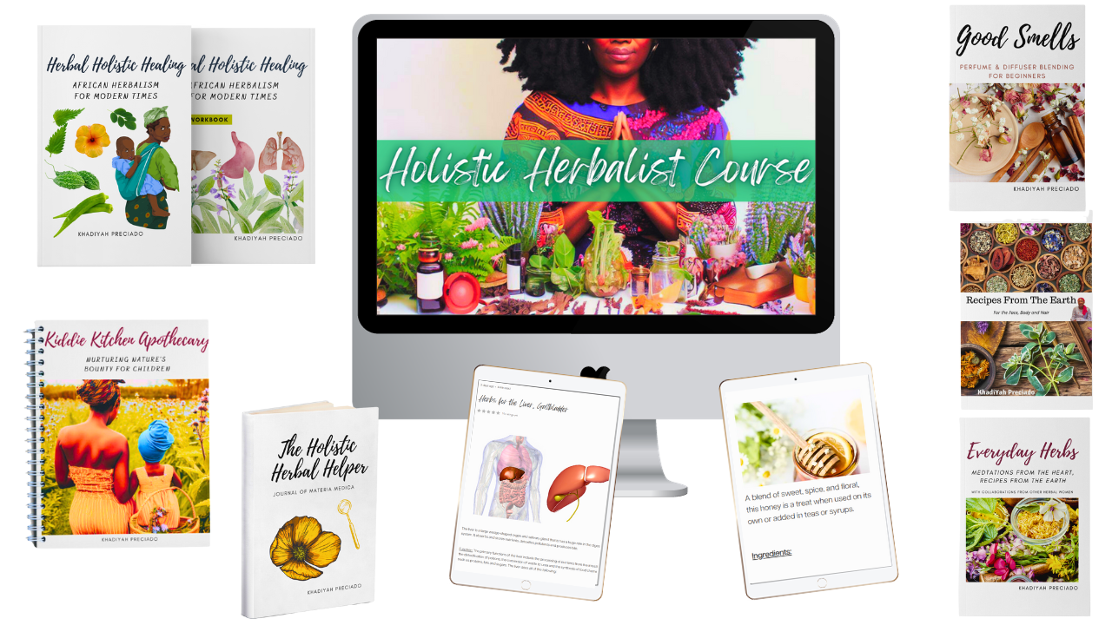
The biggest mistake that herbalists make when addressing health concerns is that they focus on symptoms, while using herbs as a quick repair. Illnesses have a root cause, they have emotions attached to them, they are the result of bad habits, poor eating, stress and many other lifestyle factors, occurring overtime. Each person and situation is different. Each herb is unique, with its own indications of use. NO MORE memorizing what herbs do or learning hundreds of herbs!

This course includes
18+ Hours of On -Demand Course Video
500+ Page Workbook
Paperback Everyday Herbs
Paperback Herbal Holistic Healing
The Holistic Herbalist Herb Journal
Complimentary Student Herb Starter kit
Downloadable Materia Medica
You will learn

African Herbalism
African Materia Medica
Herbal Safety & Drug-Herb Interactions
Herbal Energetics (Person Specific Medicine)
Recipe Creation & Wellness Programs
My T.E.A. method to make the perfect blend, every time
Colors, Tastes and its effect on the organs

Holistic medicine from a biblical perspective ​ for the price of a year of health insurance for your family!

Free 6 Mon subscription to the Practitioner Database & Library of Herbal Wisdom ($300 value)

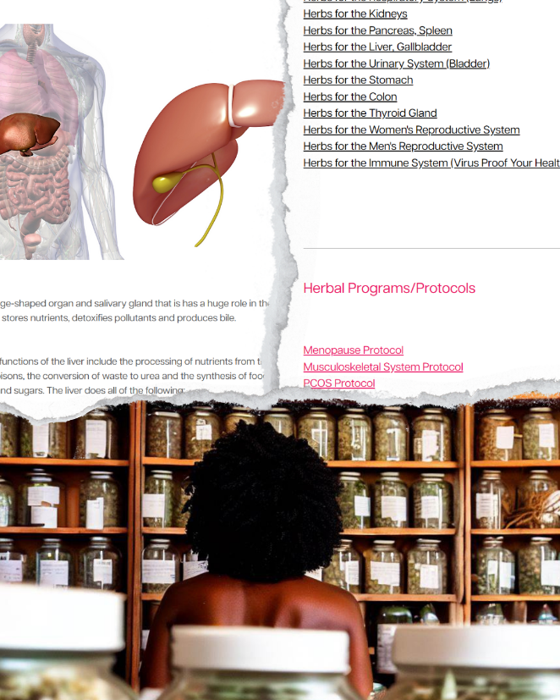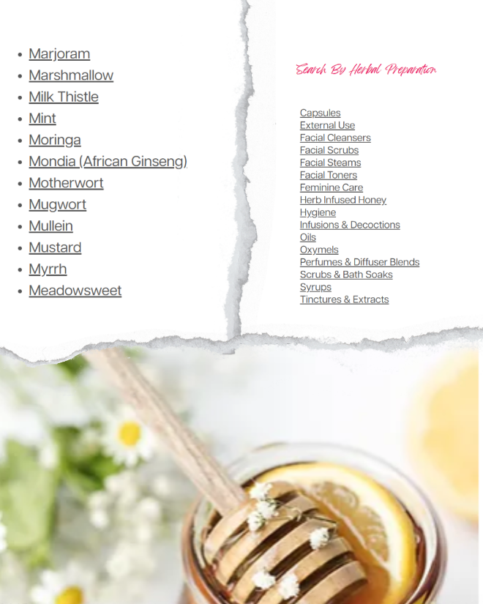

Mastering the Womb Course

View

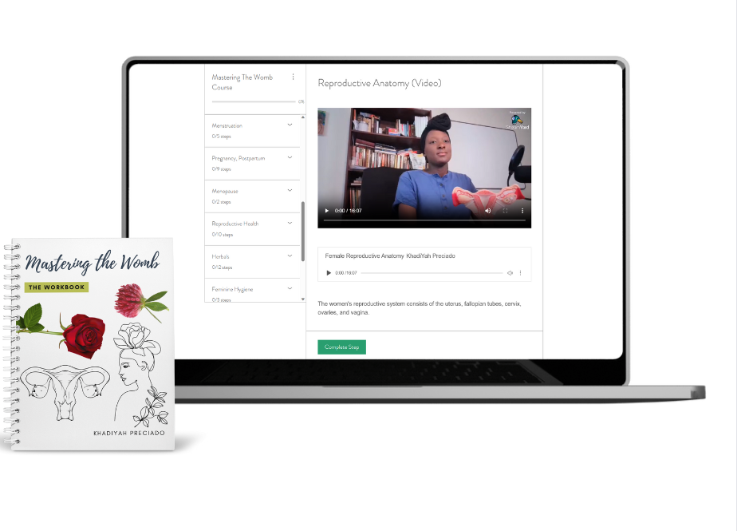
Herbs Mentioned: calendula, yarrow, nettle, raspberry leaf, chamomile, chaste tree, saw palmetto, horsetail, juniper berry, mugwort, fennel, poke, sage, chickweed, red clover and more.

I never had regular periods until I became an herbalist. We're talking about over a decade span of having sporadic periods. I went to multiple doctors, and no one was able to tell me what was going on. Then after one month of following my first herbal protocol, I finally found out how long my cycle was. I think back to the times where I had cramping and blood clotting, but I didn't know what to do.

That was my story-but it doesn't have to be yours! We're helping women go from pain, shame, confusion, barrenness, and brokenness to a happy, healthy transformed version of themselves. In this course I will explain IN DETAIL, what I did that ultimately changed my life.
Includes

The Womb Starter Kit (5 Herbs to enjoy immediately)
Printed Workbook with Notes & Recipes (start your journey ASAP)

Inside you'll find

* A breakdown of the reproductive anatomy with printable diagrams
* Explanation of Hormones, symptoms and natural plant sources and supplements.
PLUS juicy nuggets about boosting fertility for the men in our life when trying to conceive

Increase your knowledge of

Menstruation
Pregnancy, Postpartum
Breastfeeding
Menopause
Infertility

Birth Control, Regaining balance after the 💊
Alleviate abdominal cramps and heavy bleeding fast!
Prevent and shrink fibroids & cysts
Naturally boost fertility for yourself and your partner
Natural treatments for Reproductive disorders and STDs
Explore natural sources of iron, estrogen and progesterone

It is possible to regain balance and control of your body naturally with herbs. This is the holistic blueprint to mastering your womb.

Shalom!

My Name is KhadiYah Preciado. I am the wife of an army vet and the mother to two rambunctious toddlers. We live in Tennessee, but I'm originally from Queens, NY. I describe myself as a homemaker, homesteader, and homeschooling mother. I've been making my own herbal products for almost a decade. I'm a community herbalist, YouTube content creator and author in my spare time. My goal is to encourage, inspire and educate other mothers like myself, to live a happy, healthy lifestyle.

Find me on YouTube @ Her healthy home

For Courses, Classes, Products and Information
Herhealthyhome.co
Perfectlyunaltered.com

Other books include

Herbal Holistic Healing: African Herbalism for Modern Times
The Holistic Helper: Journal of Materia Medica
Everyday Herbs: Meditations of the Heart, Recipes from the Soil
Good Smells: Perfume & Diffuser Blending for Beginners
Recipes from the Earth: For the Face, Body & Hair

Books can be found on Amazon, Barnes & Noble and locally in Memphis

